**NATIONAL UNIVERSITY OF COMPUTER AND EMERGING SCIENCES**

**PROGRAM: SOFTWARE ENGINEERING**



***WEB ENGINEERING LAB***

**LAB TASK 04**

**SUBMITTED BY:**

**Name: Ahmed Ali**

**Roll No: 22P-9318**

**Section: BS(SE)-6B**

**INSTRUCTOR NAME: Sir Zakria**

**A DEPARTMENT OF COMPUTER SCIENCE**

**CODE OF QUESTION 1:**

<!DOCTYPE html>

<html lang="en">

<head>

<meta charset="UTF-8">

<meta name="viewport" content="width=device-width, initial-scale=1.0">

<title>Lab Task 4 Q1</title>

<style>

* {

margin: 100;

padding: 0;

box-sizing: border-box;

}

body {

font-family: Arial;

}

.header {

background: linear-gradient(to bottom, #2f552f, #ffffff);

padding: 10px 20px;

display: flex;

align-items: center;

justify-content: space-between;

font-size: 20px;

margin-bottom: 20px;

}

h1{

margin-bottom: 20px;

}

p{

margin-bottom: 20px;

}

.logo {

height: 50px;

}

.container {

flex-grow: 1;

display: flex;

justify-content: center;

}

.menu {

list-style: none;

display: flex;

}

.menu li {

padding: 15px 20px;

color: white;

font-weight: bold;

cursor: pointer;

}

.menu li:hover {

background: #ffffff33;

border-radius: 5px;

}

.contact-section {

padding: 50px;

text-align: center;

background-color: #f4f4f4;

}

.contact-container {

display: flex;

justify-content: center;

gap: 20px;

}

.contact-box {

background: white;

padding: 20px;

border-radius: 10px;

box-shadow: 0 0 10px #0000001a;

width: 300px;

text-align: center;

}

.contact-box h3 {

margin-bottom: 10px;

}

.contact-form-section {

display: flex;

padding: 50px;

background-color: #ffffff;

justify-content: center;

gap: 20px;

}

.contact-form-container {

width: 50%;

text-align: left;

}

.contact-form-container h2 {

font-size: 24px;

margin-bottom: 20px;

}

.form-group {

display: flex;

flex-direction: column;

width: 100%;

margin-bottom: 15px;

}

.form-group div {

width: 100%;

margin-bottom: 10px;

}

.form-group input, .full-width {

width: 100%;

padding: 10px;

border: 1px solid #ccc;

border-radius: 5px;

}

.full-width-label {

display: block;

text-align: left;

font-weight: bold;

margin-bottom: 5px;

}

.button-container {

margin-top: 20px;

display: flex;

justify-content: center;

}

.contact-form-container button {

background-color: #2f552f;

color: white;

padding: 10px 20px;

border: none;

border-radius: 5px;

cursor: pointer;

font-size: 16px;

}

.contact-form-container button:hover {

background-color: #1e3e1e;

}

.contacts-directory {

padding: 50px;

text-align: center;

background-color: #f4f4f4;

}

.contacts-directory h2 {

font-size: 40px;

color: dimgray;

margin-bottom: 20px;

font-weight: bold;

}

table {

width: 60%;

margin: 0 auto;

border-collapse: collapse;

background: white;

box-shadow: 0 0 10px #0000001a;

}

th, td {

border: 1px solid #ddd;

padding: 10px;

text-align: left;

}

th {

background-color: white;

font-size: 24px;

color: black;

font-weight: bold;

}

.footer {

background-color: #263f49;

color: white;

padding: 40px 0;

font-family: Arial;

}

.footer-container {

display: flex;

justify-content: space-around;

flex-wrap: wrap;

max-width: 1200px;

margin: auto;

padding: 20px;

}

.footer-left, .footer-center, .footer-right {

flex: 1;

min-width: 250px;

margin: 10px;

}

.footer-left h2 {

font-size: 18px;

margin-bottom: 10px;

}

.footer-left p {

font-size: 14px;

margin-bottom: 8px;

}

.footer-left strong {

color: #b4d4b4;

}

.social-icons {

margin-top: 10px;

}

.social-icons img {

width: 30px;

margin-right: 10px;

cursor: pointer;

}

.footer-center h3,

.footer-right h3 {

font-size: 18px;

margin-bottom: 10px;

}

.footer-center ul,

.footer-right ul {

list-style: none;

padding: 0;

}

.footer-center li,

.footer-right li {

font-size: 14px;

padding: 5px 0;

color: #b4d4b4;

}

.footer-bottom {

text-align: center;

padding: 15px;

background-color: #172d17;

font-size: 14px;

}

.footer-bottom strong {

color: #b4d4b4;

}

</style>

</head>

<body>

<header class="header">

<img src="logo.png" alt="Logo" class="logo">

<div class="container">

<ul class="menu">

<li>Home</li>

<li>About Us</li>

<li>Success Stories</li>

<li>NFE</li>

<li>Schemes</li>

<li>Media</li>

<li>Downloads</li>

<li>POHA</li>

<li>Contact Us</li>

</ul>

</div>

</header>

<section class="contact-section">

<h1>Contact Us</h1>

<p>Got a question? We would love to hear from you. Send us a message and we will respond as soon as possible.</p>

<div class="contact-container">

<div class="contact-box">

<h3>Our Address</h3>

<p>Elementary & Secondary Education Foundation</p>

<p>Plot No.20, Street No.13, Sector E-8, Phase-7, Hayatabad, Peshawar, Khyber Pakhtunkhwa</p>

</div>

<div class="contact-box">

<h3>Email Us</h3>

<p>info@eef.org.pk</p>

</div>

<div class="contact-box">

<h3>Call Us</h3>

<p>091-9219106, 9219107</p>

</div>

</div>

</section>

<section class="contact-form-section">

<iframe src="https://maps.google.com/maps?q=Elementary%20and%20Secondary%20Education%20Foundation&t=&z=13&ie=UTF8&iwloc=&output=embed" width="50%" height="400" style="border:0;" allowfullscreen loading="lazy"></iframe>

<div class="contact-form-container">

<h2>Send us a message</h2>

<div class="form-group">

<div>

<label for="name">Name *</label>

<input type="text" id="name" placeholder="Your Name" required>

</div>

<div>

<label for="email">Email *</label>

<input type="email" id="email" placeholder="Your Email" required>

</div>

</div>

<label class="full-width-label" for="subject">Subject *</label>

<input type="text" id="subject" placeholder="Subject" class="full-width" required>

<label class="full-width-label" for="message">Message *</label>

<textarea id="message" placeholder="Message" class="full-width" rows="5" required></textarea>

<div class="button-container">

<button type="submit">Send Message</button>

</div>

</div>

</section>

<section class="contacts-directory">

<h2>Contacts Directory</h2>

<table>

<tr>

<th>Designation</th>

<th>Telephone No</th>

<th>Email</th>

</tr>

<tr>

<td>Managing Director Office</td>

<td>919219999</td>

<td>md@eef.org.pk</td>

</tr>

<tr>

<td>Deputy Managing Director Office</td>

<td>919219999</td>

<td>deputy.md@eef.org.pk</td>

</tr>

<tr>

<td>Director Program Office</td>

<td>919219125</td>

<td>dpoffice@gmail.com</td>

</tr>

<tr>

<td>Exchange Office</td>

<td>9219106108</td>

<td></td>

</tr>

<tr>

<td>DPO D.I.Khan</td>

<td>0966-9280430</td>

<td>dikhan@eef.org.pk</td>

</tr>

<tr>

<td>DPO Tank</td>

<td>0966-510537</td>

<td>tank@eef.org.pk</td>

</tr>

<tr>

<td>DPO Bannu</td>

<td>09286622909</td>

<td>bannu@eef.org.pk</td>

</tr>

<tr>

<td>DPO Lakki Marwat</td>

<td>0969-511404</td>

<td>lakkimarwat@eef.org.pk</td>

</tr>

<tr>

<td>DPO Karak</td>

<td>0927-210786</td>

<td>karak@eef.org.pk</td>

</tr>

</table>

</section>

<footer class="footer">

<div class="footer-container">

<div class="footer-left">

<h2>Elementary & Secondary Education Foundation <br> Khyber Pakhtunkhwa</h2>

<p>Plot No.20, Street No.13, Sector E-8,<br> Phase-7, Hayatabad, Peshawar</p>

<p><strong>Phone:</strong> 091-9219106, 9219107</p>

<p><strong>Email:</strong> info@eef.org.pk</p>

<div class="social-icons">

<img src="twitter-icon.png" alt="Twitter">

<img src="facebook-icon.png" alt="Facebook">

<img src="instagram-icon.png" alt="Instagram">

<img src="youtube-icon.png" alt="YouTube">

</div>

</div>

<div class="footer-center">

<h3>Our Services</h3>

<ul>

<li>Girls Community Schools</li>

<li>Education Support Scheme</li>

<li>New Schools Initiative</li>

<li>Downloads</li>

<li>Contact Us</li>

</ul>

</div>

<div class="footer-right">

<h3>Useful Links</h3>

<ul>

<li>Apply For GCS</li>

<li>Apply For ESS</li>

<li>Apply For NSI</li>

<li>Elementary & Secondary Education Department</li>

<li>Sindh Education Foundation</li>

<li>Punjab Education Foundation</li>

<li>Higher Education Department</li>

<li>Education Monitoring Authority</li>

<li>ETEA</li>

</ul>

</div>

</div>

<div class="footer-bottom">

<p>&copy; Copyright (2022) <strong>Elementary & Secondary Education Foundation, Govt. of Khyber Pakhtunkhwa.</strong> All Rights Reserved</p>

<p>Designed by Ahmed</p>

</div>

</footer>

</body>

</html>

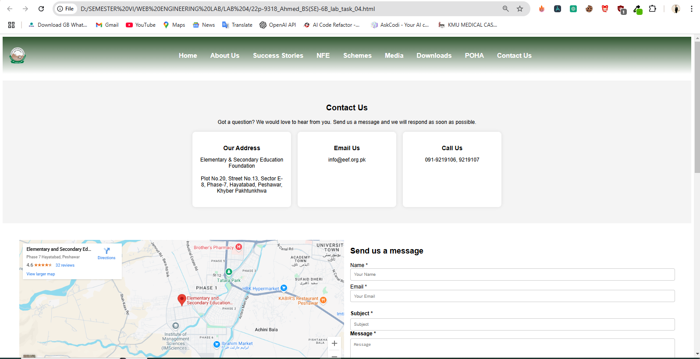**ScreenShot Q1:**

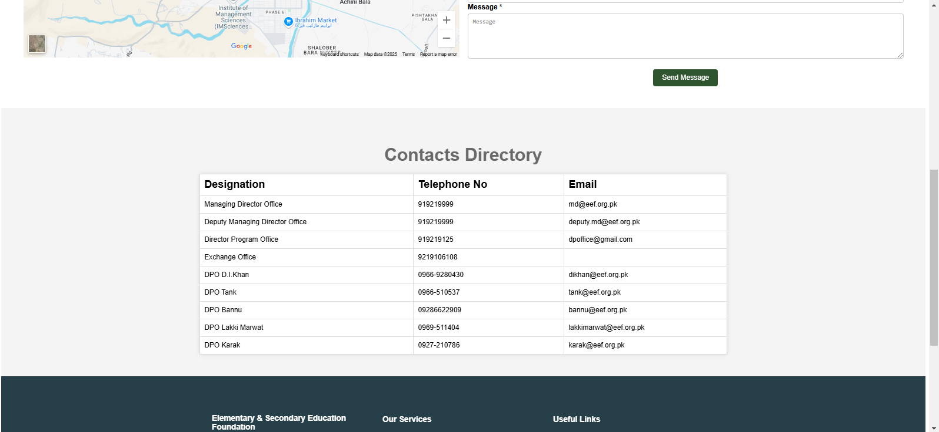

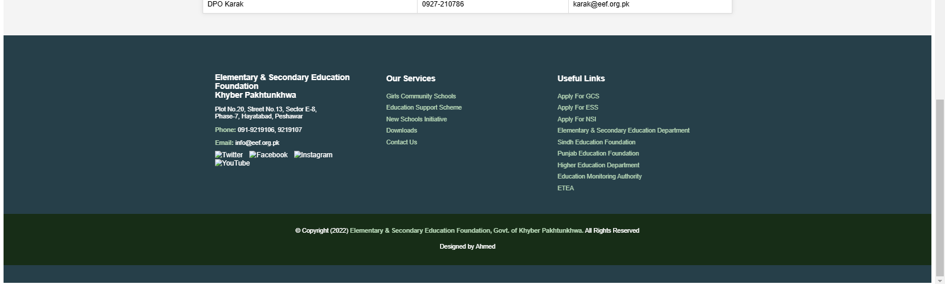

**CODE OF QUESTION 2:**

<!DOCTYPE html>

<html lang="en">

<head>

<meta charset="UTF-8">

<title>Lab Task 4 Q2</title>

<style>

* {

margin: 0;

padding: 0;

box-sizing: border-box;

font-family: Arial, sans-serif;

}

body {

background-color: #f0f8ff;

line-height: 1.6;

display: grid;

grid-template-rows: auto 1fr auto;

min-height: 100vh;

}

.container {

max-width: 1200px;

margin: 0 auto;

padding: 20px;

display: grid;

gap: 20px;

}

.header {

background-color: #52B700;

padding: 10px;

color: #333;

}

.header-container {

display: grid;

grid-template-columns: auto 1fr;

align-items: center;

gap: 20px;

max-width: 1200px;

margin: 0 auto;

}

.logo img {

height: 100px;

}

.header-nav ul {

display: grid;

grid-template-columns: repeat(4, auto);

gap: 10px;

list-style: none;

justify-content: end;

}

.main-content {

display: grid;

gap: 20px;

padding: 20px;

}

.welcome-section {

background-color: #fff;

padding: 80px;

border-radius: 8px;

box-shadow: 0 0 10px rgba(0, 0, 0, 0.1);

text-align: left;

}

.welcome-section h1 {

color: #228B22;

margin-bottom: 10px;

}

.categories-section {

display: grid;

grid-template-columns: repeat(auto-fit, minmax(250px, 1fr));

gap: 20px;

}

.category-box {

background-color: #fff;

padding: 20px;

border-radius: 8px;

box-shadow: 0 0 10px rgba(0, 0, 0, 0.1);

text-align: center;

border: 2px solid #228B22;

}

.category-box img {

max-width: 100%;

height: auto;

margin-bottom: 10px;

}

.category-box h2 {

color: #228B22;

}

.footer {

background-color: #52B700;

padding: 20px;

color: #333;

text-align: center;

}

.footer-container {

display: grid;

grid-template-columns: repeat(auto-fit, minmax(250px, 1fr));

gap: 20px;

max-width: 1200px;

margin: 0 auto;

}

</style>

</head>

<body>

<header class="header">

<div class="header-container">

<div class="logo">

<img src="logo.png" alt="POHA LMS Logo">

</div>

<nav class="header-nav">

<ul>

<li>Home</li>

<li>Subjects</li>

<li>Ahmed</li>

<li>Logout</li>

</ul>

</nav>

</div>

</header>

<main class="main-content">

<section class="welcome-section">

<h1>WELCOME TO POHA LMS</h1>

<p>Lorem ipsum dolor sit amet, consectetur adipisicing elit, sed do eiusmod

tempor incididunt ut labore et dolore magna aliqua. Ut enim ad minim veniam,

quis nostrud exercitation ullamco laboris nisi ut aliquip ex ea commodo

consequat. Duis aute irure dolor in reprehenderit in voluptate velit esse

cillum dolore eu fugiat nulla pariatur. Excepteur sint occaecat cupidatat non

proident, sunt in culpa qui officia deserunt mollit anim id est laborum.</p>

</section>

<section class="categories-section">

<div class="category-box">

<img src="lession.png" alt="Lessons">

<h2>LESSONS</h2>

</div>

<div class="category-box">

<img src="card-img.png" alt="Examination">

<h2>Examination</h2>

</div>

<div class="category-box">

<img src="result.png" alt="Home Work">

<h2>HOME WORK</h2>

</div>

<div class="category-box">

<img src="feed_back.png" alt="Chat">

<h2>CHAT</h2>

</div>

</section>

</main>

<footer class="footer">

<div class="footer-container">

<div class="footer-info">

<p>Elementary & Secondary Education Foundation Khyber Pakhtunkhwa</p>

<p>Plot No. 20, Street 13, Sector E8, Phase 7, Hayatabad, Peshawar</p>

<p><a href="mailto:info@eef.org.pk">info@eef.org.pk</a></p>

<p>091-9219106</p>

</div>

<div class="footer-links">

<h3>Quick Links</h3>

<ul>

<li>Home</li>

<li>About POHA</li>

</ul>

</div>

<div class="footer-useful-links">

<h3>Useful Links</h3>

<ul>

<li>E-Lab</li>

<li>About POHA</li>

</ul>

</div>

</div>

</footer>

</body>

</html>

**SCREENSHOT Q2:**

